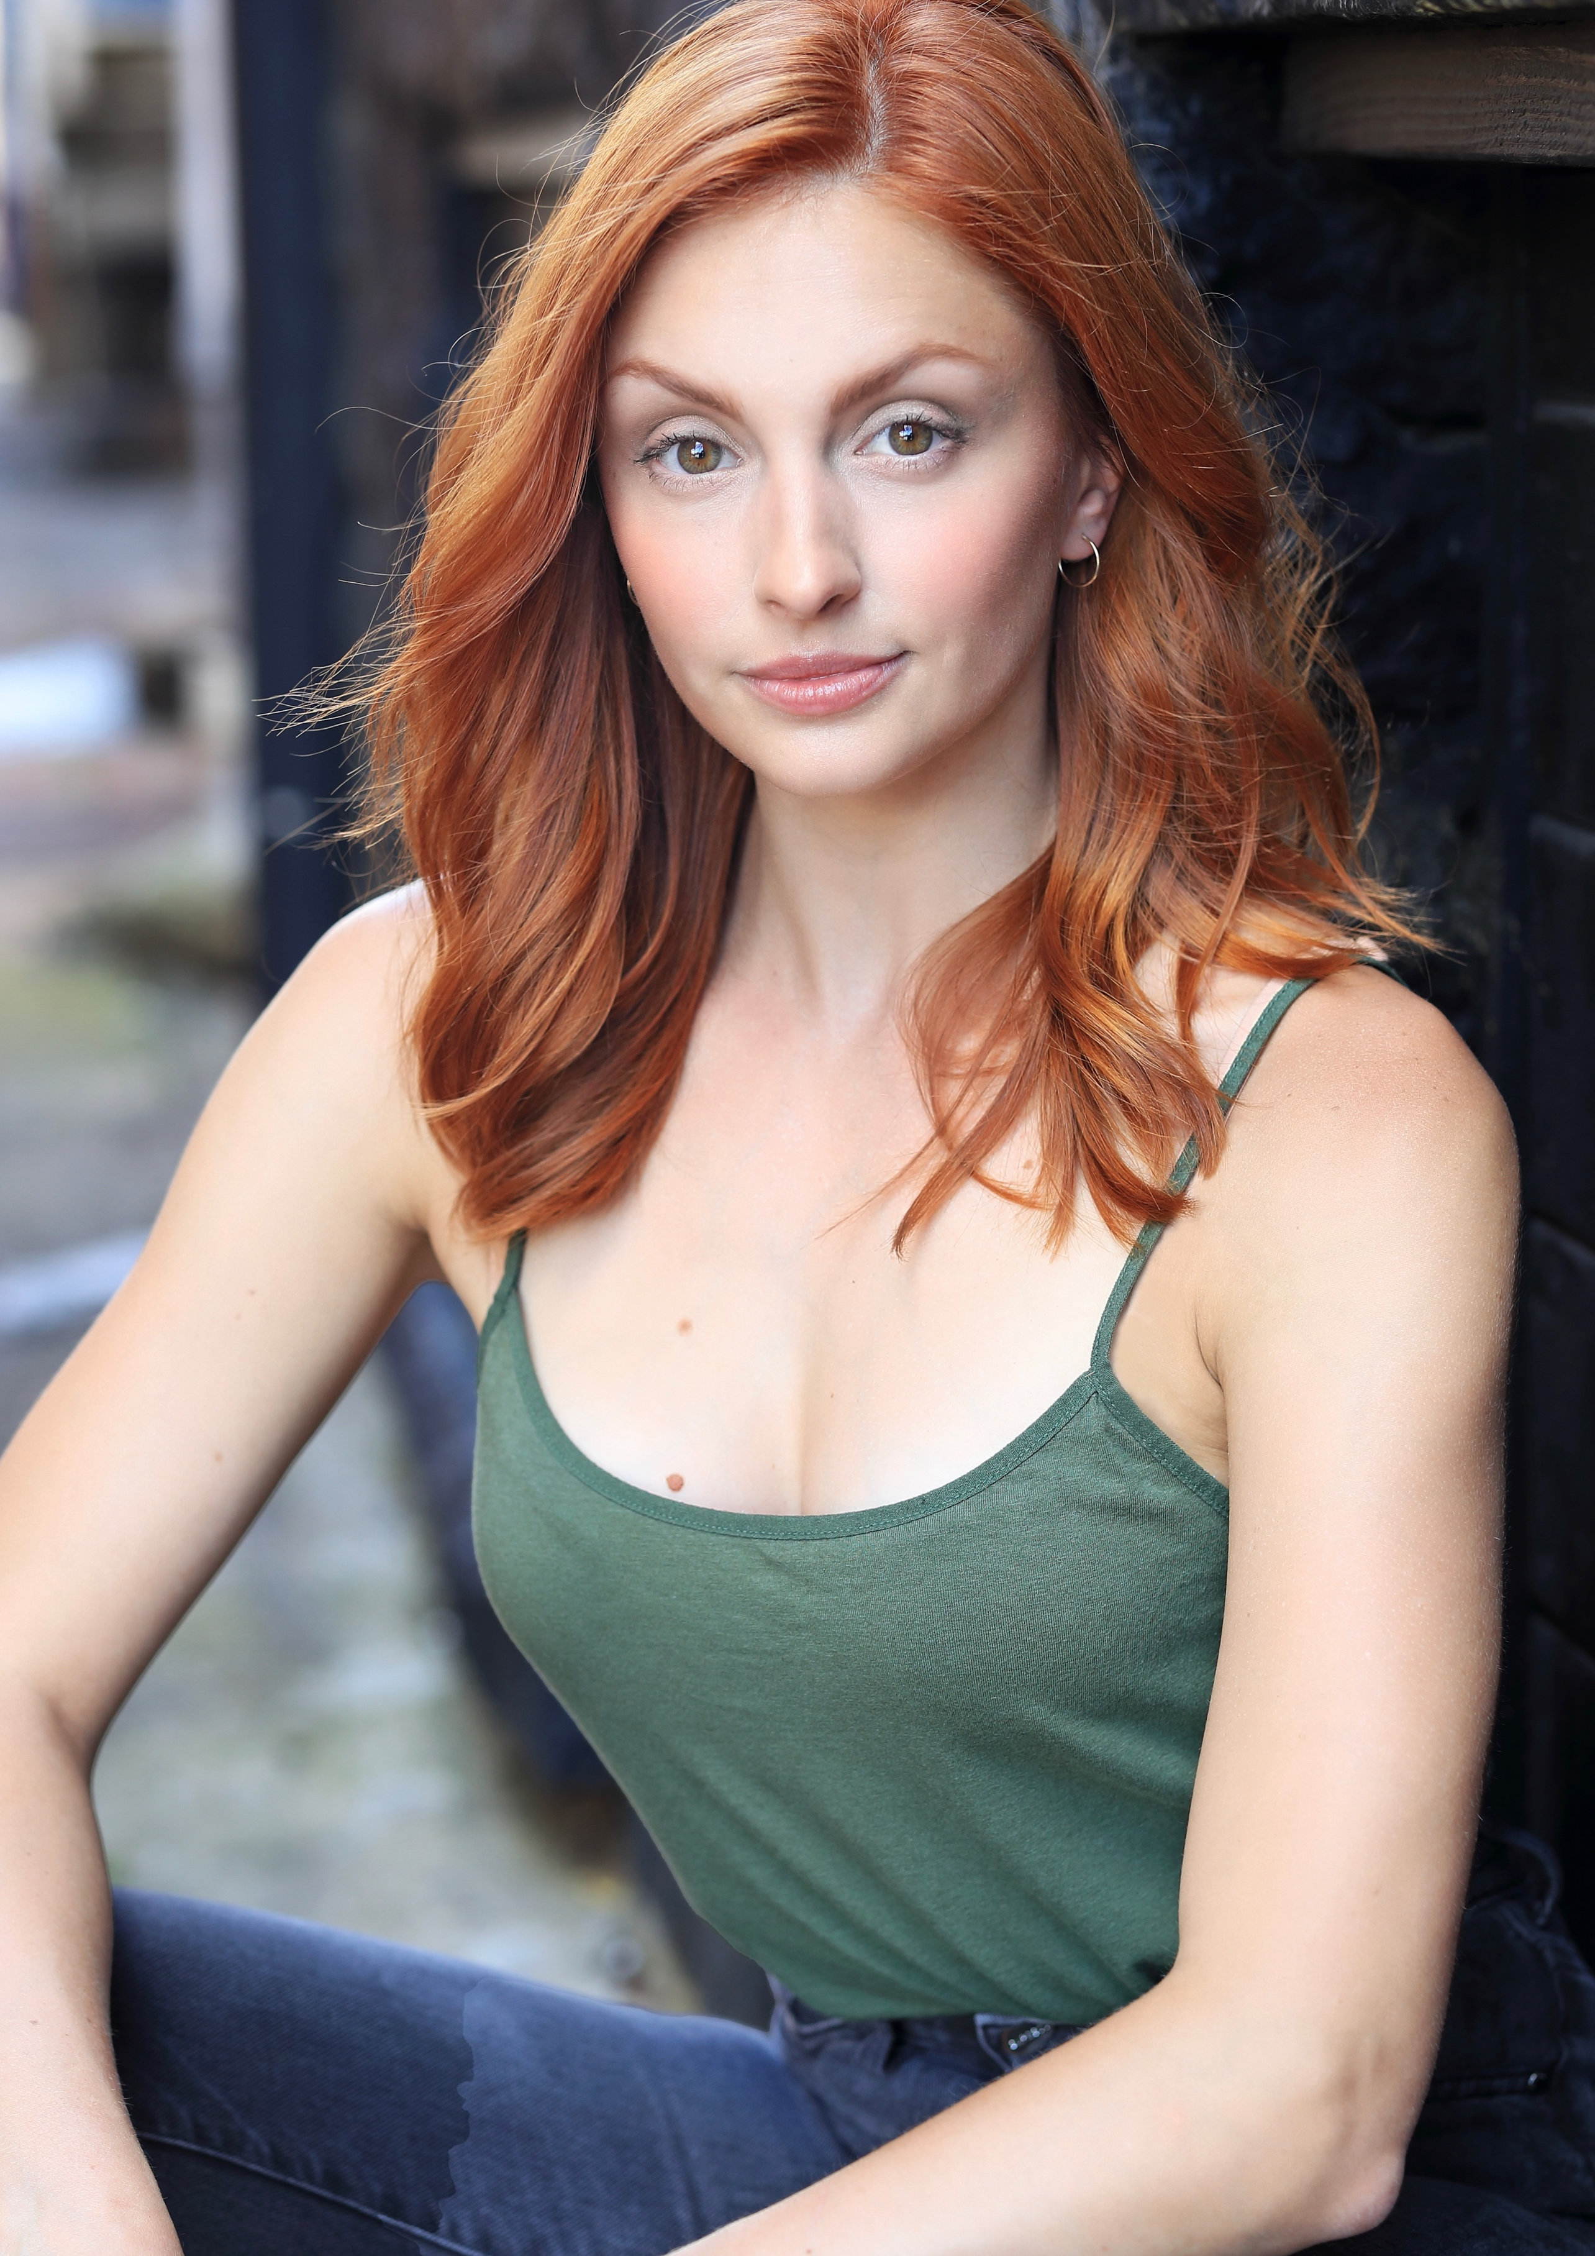
LEXIS DANCA

AEA

Height: 5’7”
Vocal Range : Soprano/Belter (G3-C6)

TV/Commercial
HUSTLING Jamie Episodic
National- Alive Multivitamins! Principal Nature Valley
Fresh Direct Grocery Delivery Principal Robbins Digital Media NYC
DARCARS Industrial Host Robbins Digital Media NYC
RDM Internal Host Robbins Digital Media NYC
WSHE 100.3 Cable Spot Principal Hubbard Radio
Tiege Hanley Skincare Principal Guy Bauer Productions
"Just Drive: Distracted Driving" PSA Principal National Safety Council

Theater
Sondheim’s THE FROGS Core Dancer Jazz at Lincoln Center
34th Annual Easter Bonnet Competition Core Ensemble Dancer The Minskoff Theatre
Steel Magnolias Shelby Eatenton Latcherie Flat Rock Playhouse
Million Dollar Quartet Dyanne Flat Rock Playhouse
Anything Goes Hope Harcourt Music Theater Works
MAMMA MIA! Sophie Sheridan Music Theatre Wichita
Gypsy Louise Music Theater Works
Beauty and the Beast Babette Music Theatre Wichita
Million Dollar Quartet U/S Dyanne The Marriott Theatre
Something Rotten U/S Portia/ Ensemble The Marriott Theatre
Matilda U/S Miss Honey/ Ensemble Drury Lane Theatre
Sweet Charity Rosie/Ensemble The Marriott Theatre
Joseph & the Amazing... Potiphar's Wife/Ensemble Drury Lane Theatre
A Wonderful Life Dorothy/Ensemble U/S Violet Theatre at the Center
Oklahoma! Dance Captain/Ensemble Music Theatre Wichita
Seussical U/S Birdgirl & Mrs. Mayor The Marriott Theatre
Oliver! Ensemble The Marriott Theatre
Nice Work if You Can Get it Ensemble Music Theatre Wichita
Jesus Christ Superstar Ensemble Music Theatre Wichita
Big Fish Ensemble Music Theatre Wichita
Hello, Dolly! Ensemble Music Theatre Wichita
My Son, Pinocchio Ensemble Music Theatre Wichita
Billy Elliot Ensemble Music Theatre Wichita
Aida Ensemble Music Theatre Wichita
Macy's Thanksgiving Day Parade Featured Dancer/Singer NBC/Office Depot
An Evening with Andrew Lippa Featured Vocalist Andrew Lippa

Training
Millikin University BFA Musical Theatre, Dance Minor
Vagabond School of the Arts On Camera Training
Voice Anne Borders/Roberta Duchak/Matthew Ellenwood
Stagedoor Manor Acting/Dance/Vocal training

Special Skills
Dance
18+ years classical training) BALLET, JAZZ, POINTE, TAP, MODERN- Splits, fouettes, dance en pointe
Dialects
BRITISH, COCKNEY, FRENCH, IRISH, RUSSIAN

